- Check lại count for TT-seq1 --> okie
- Thực hiện SpikeInFree trên sorted.human.bam file cho tất cả các replicate đều ok, signal tốt. Scaling factor của một trong các input =1, còn lại khác 1 --> hợp lý với lý thuyết về cách tính SF là chọn 1 sample trong 1 group rồi từ đó tính bằng cách chia nó cho slope
- Chỉ hơi thắc mắc lệnh htseq-count --> nên chạy lại với tham số khác để so sánh giữa ba option cho -i là gene_id và transcriptId và gene_name
-m union --nonunique all -f bam -s no -t transcript -i gene_id

Kết quả với 3 para khác nhau trên human:
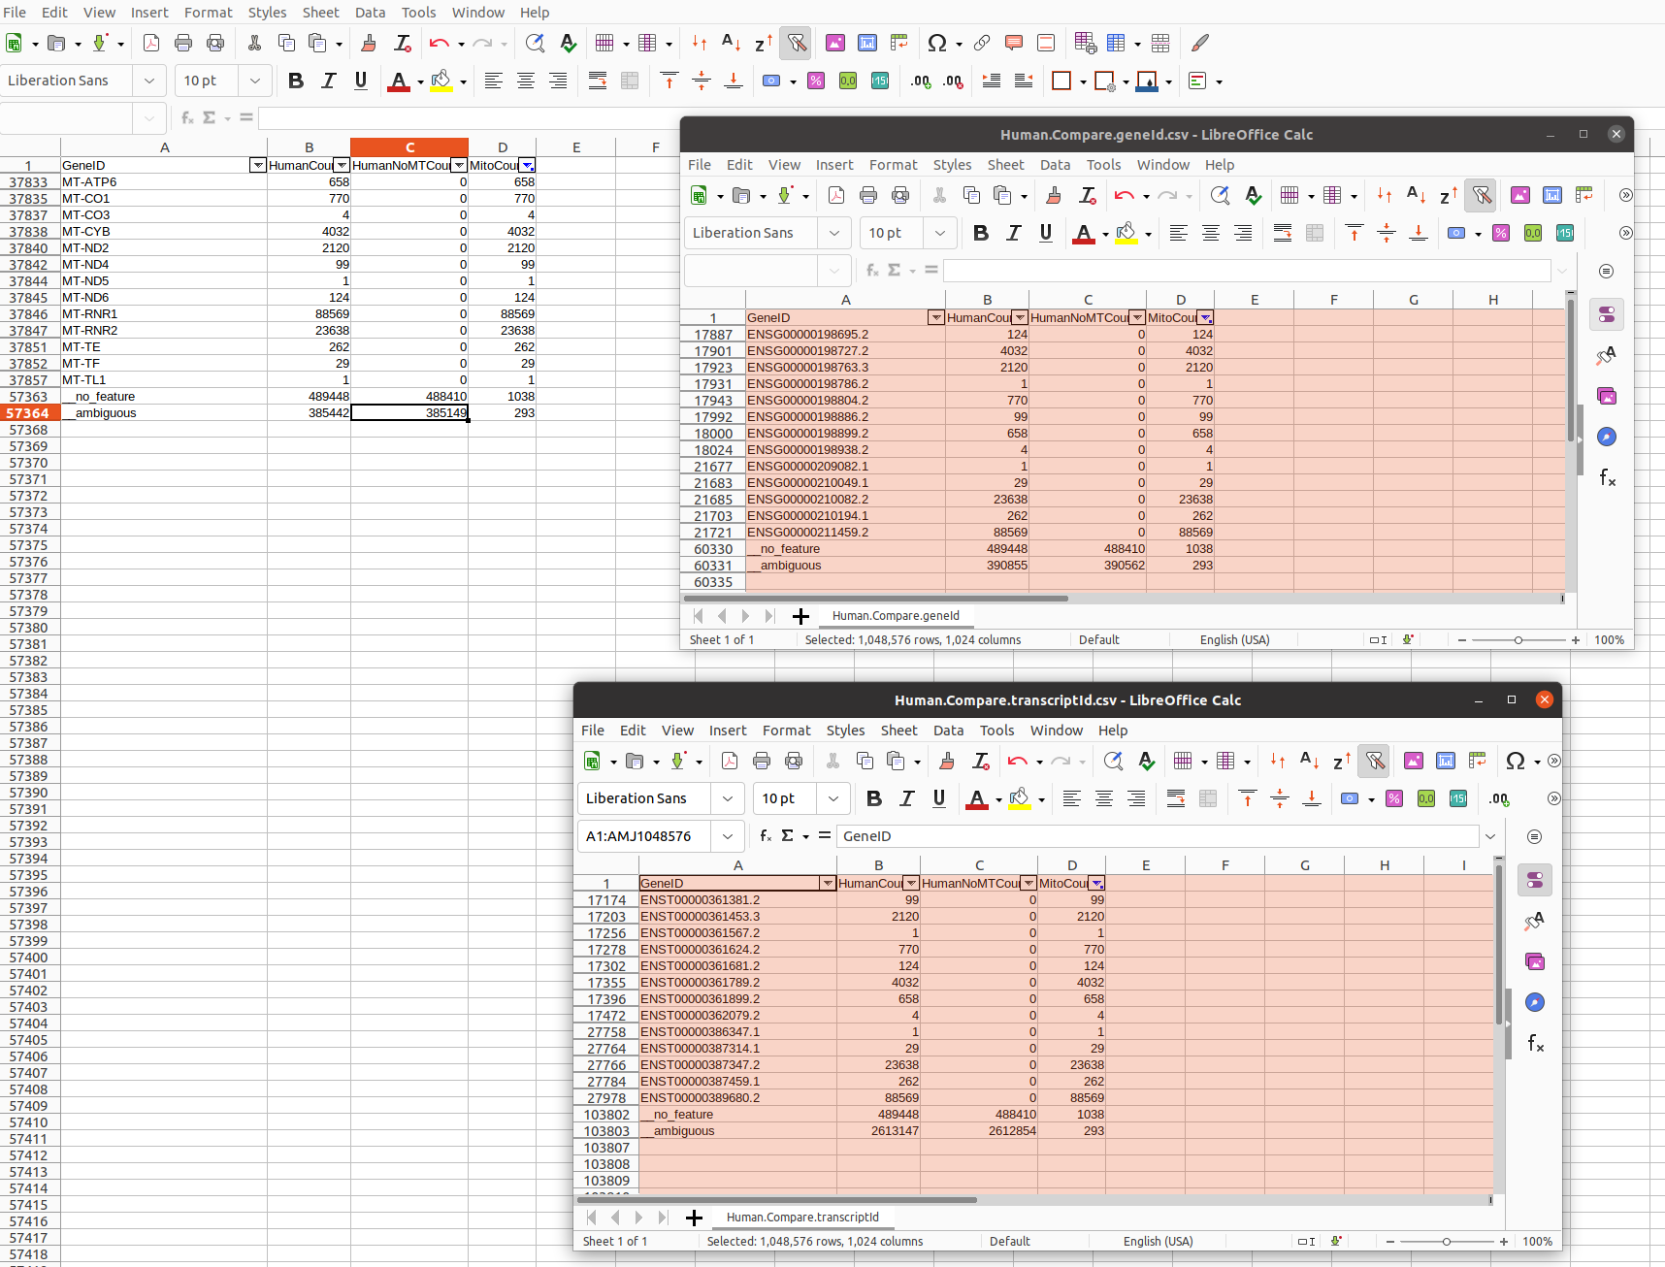

Kết quả với 3 para khác nhau trên mouse:
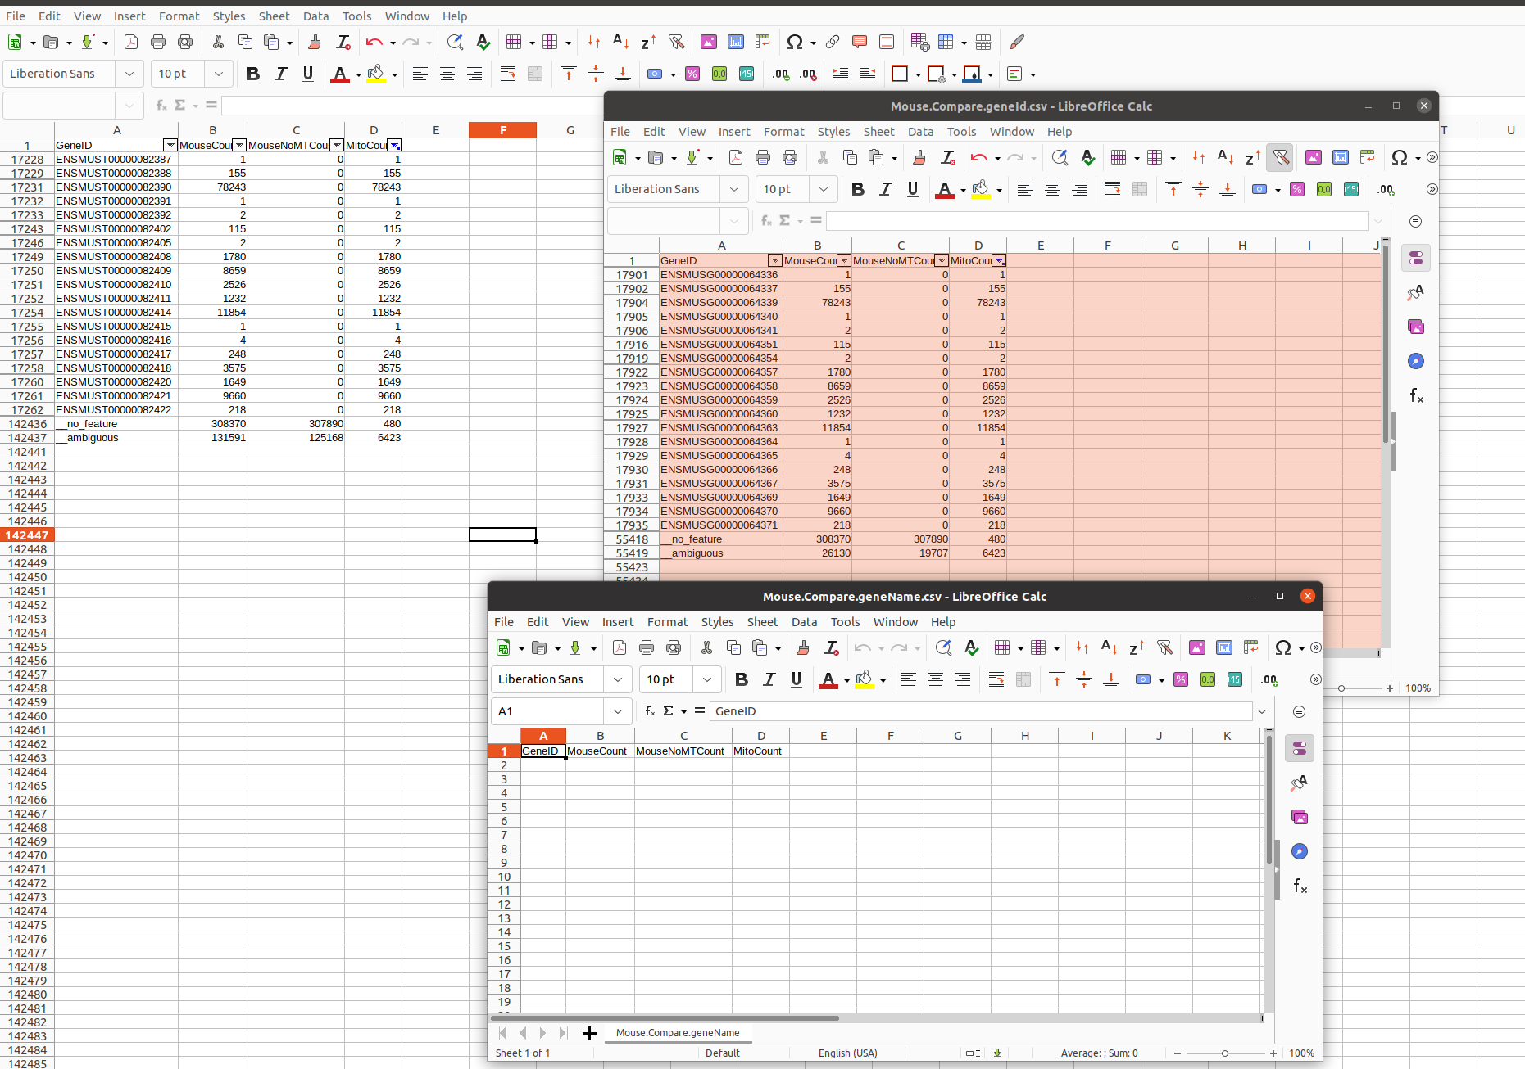
Ko hiểu sao với gene_name trên mouse thì kết quả bằng 0 mặc dù xem trên gtf file tương ứng vẫn có
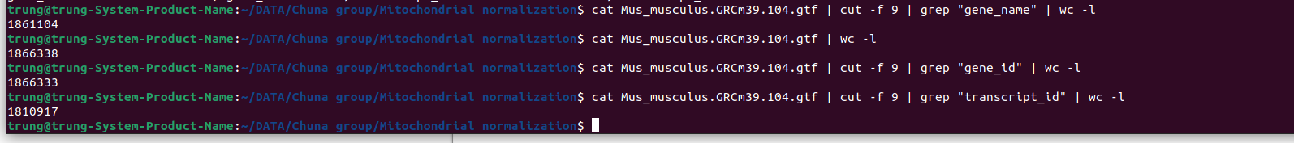
Dựa trên thống kê trên thì dùng gene_id làm feature để call ht-seq count là ổn nhất

So sánh tổng số read count bằng ht-seq count với feature là gene-id và bằng lệnh samtools view uniq và đếm số dòng thì kq bằng lệnh samtools view cao hơn 1 chút??? --> dùng lệnh rmdup để remove dup rồi check lại --> kết quả là rmdup trên human count ko được gene nào còn mouse thì ok? ko biết có sai tên file ko nữa --> đã check do sai code nên file bị ghi đè

Trước khi dùng rmdup, check lại log thì thấy ht-seq báo ko có index file nhưng vẫn count được --> chạy lại ht-seq count với sorted.bam file để xem kết quả có khác ko --> kết quả như cũ, chỉ là file log ko báo là cần phải index bam file nữa

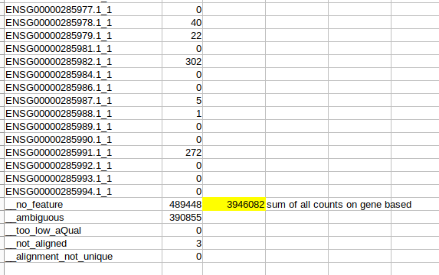

- Vừa google vừa đọc và take note để hiểu các khái niệm xung quanh những paper giáo sư đưa

- dTag: degradation tag (dTAG) = short peptide sequences that mark a protein for degradation by the cell's protein recycling machinery. By doing so, the degradation tag effectively decreases the protein half-life or the typical length of time that a proteins, once translated, will exist in the cell. (Formally, the half-life is the interval time it takes for the level of the protein to decay to half its initial value). In practive, adding a degradation tag will also tend to decrease the concentration of the protein in the cell
( http://parts.igem.org/Protein_domains/Degradation)

- Use of degradation tags to control protein levels

- DMSO (Dimethyl Sulfoxide) is a polar, aprotic organic solvent that is commonly used as a cryoprotectant because of its membrane penetrating and water displacement properties. It is added to cell culture media to reduce ice formation and thereby prevent cell death during the freezing process.

- As a cryoprotective agent, DMSO is added to cell freezing medium to prevent the formation of ice crystals during the freezing process, otherwise cells would be destroyed and dead. It is commonly used in cell banking. DMSO has a low toxicity to cells.

-Primary cell culture is the culture of cells directly isolated from parental tissue of interest; whereas cell line is the culture of cell originated from a primary cell culture, which is generally used to expand cell population and prolong life span.

Differences between the two:

- Resemblance to parental tissue: Cells in primary culture closely resemble the parental tissue, while cells in a cell line might have mutations or genetic alterations during sub-culturing.
Process of obtaining cells: In primary cell culture, cells are isolated from tissues, which usually go through phases of rinsing, dissection, mechanical or enzymatic disaggregation, and separation. In contrast, obtaining cells for a cell line is much more straightforward, which are directly transferred from the primary cell culture. If the primary cell is an adherent type, a detaching step is required.
Life span: Primary cell cultures have finite life spans because the growth of cells exhausts substrate and nutrients, during which toxic metabolites are also accumulated, leading to the death of cells. However, cell lines have prolonged lifespan. Periodic sub-culturing can even produce immortal cells through transformation or genetic alteration of primary cells.
Risk of contamination: Primary cell cultures are more difficult to take care of, which has a higher risk of contamination than the cell line.

TT-seq
-The transcriptome of polymerase (Pol) II consists
Of messenger RNA (mRNA) encoding proteins and non-coding RNA (ncRNA). Due to their
short half-life ncRNAs are not easy to catch and thus, many of their functions remain elusive. To this end we developed transient-transcriptome sequencing (TT-seq) to detect and map
transient full-length RNAs in vivo.

Cần chú ý là TT-seq và ChIP-seq đều có liên quan đến Pol II, vì Pol II transcribes messenger RNA và non-coding RNA

Cần biết thêm, chi tiết về TT-seq và transcription, có thể xem ở đây: https://edoc.ub.uni-muenchen.de/19932/13/Michel_Margaux.pdf

Transient RNAs
The most studied RNAs in living organisms are usually the ones that are the most stable and
therefore easy to purify and analyze. RNAs that only live for few minutes are very hard to
catch. Therefore, for a long time only protein-coding transcripts were assumed to be
transcribed by Pol II and that the transcriptome represented only a very small percentage of
the genome. Recent advances in methodologies and technologies, primarily the development
of next-generation sequencing, have revoked this concept and showed that 90% of the human
genome is transcribed (Wang et al, 2009; Wilhelm et al, 2008). This uncovered a multitude of
ncRNAs with many different crucial functions for cell development and identity.

ncRNAs can be long ( ̴10 kb; lncRNAs) or short ( ̴1 to
5 kb). Short ncRNAs can emerge from promoter regions or enhancer regions (eRNAs).
Furthermore, short ncRNAs are dispersed in the genome, such as upstream of the TSS of a
protein-coding gene (mRNA), on the opposite strand of an mRNA or far away from any
annotated future

RNA degradation pathways: có thể giúp làm hiểu rõ hơn các điều kiện DMSO, dTag…

Analyzing transient RNAs
Nuclear run-on assays such as PRO-seq/PRO-cap (Kwak et al, 2013), GRO-seq (Core et al,
2008b) or GRO-cap (Core et al, 2014), are one of the most sensitive methods when it comes
to transient RNAs. Downside of these methods is that they are rather experimentally
complicated and per se in vitro, since one isolates nuclei and resumes transcription with
labeled and unlabeled nucleotides. CAGE is another sensitive method but similar to GRO-cap
or PRO-cap it does not map transcripts in their full length but only their 5’ ends (Shiraki et al,
2003).

Example of Pol II synthesis rate: 2 to 4 kb/min

Studies of eRNAs
Since the discovery that the majority of the human genome is transcribed (Wilhelm et al,
2008), the question arose if all transcripts are functional or if ncRNAs are a mere by-product
of the transcription of protein-coding genes (Palazzo & Lee, 2015). Furthermore, since the
discovery of eRNAs, it is still an open question in the field if eRNAs are functional or not,
and how their transcription is coupled to their target promoter (Li et al, 2016). Most of the
functions, occurrence, abundance and kinetics of ncRNAs in cells remain elusive due to the
lack of an adequate experimental protocol. Most of the methods used so far are either in vitro,
not genome-wide, and/or under perturbed cellular conditions such as deletion or depletion of
cellular factors. Furthermore, these methods lack sensitivity and/or do not map RNAs in their
full-length but are rather biased towards their 5’ or 3’ end (Arner et al, 2015; Core et al, 2014;
Kwak et al, 2013; Preker et al, 2008).

Spike-in
Spike-ins are crucial for normalization when comparing different samples within an experiment. They are synthetic probes that do not match any sequence in the human genome in order to clearly differentiate them from sequences from your biological experiment. Spikeins are added at the beginning of an experiment to every sample in the same amount. They serve as an internal standard and can correct for global changes in RNA amount between different samples. The idea to use spike-ins is based on a similar approach developed in the Cramer lab for S. cerevisiae (Sun et al, 2012).

ChIP-qPCR
A qPCR was performed to ensure enrichment of the immunoprecipitated DNA over background. Primers were chosen depending on the antibody used, but usually primers binding over the promoter, the TSS, the gene body in exon and introns or near the poly A site were chosen (Table 8). The qPCR reaction was mixed with 1 µl DNA, 10 µl 2x SensiFAST SYBR mix, 0.8 µl each of 10 µM forward and reverse primers (Table 8) and filled to 20 µl with ddH2O. Cycling conditions can be found in Table 11 “qPCR”. Analysis of the qPCR was performed by calculating the “% Input”: the enrichment of specific DNA sequences in the IP sample over the Input sample: % Input = 100 ∗ 2 ((Ct(Input)−log2(100))−Ct(IP))

Transcripts arise from promoters but also from enhancers, which are regulatory elements with characteristic chromatin modifications (Djebali et al, 2012, Kim et al, 2010b). To detect chromatin regions comprising putative enhancers and promoters (chromatin states), we applied GenoSTAN (Zacher et al, 2016) to ENCODE ChIP-seq data (Consortium, 2012), for the coactivator p300 and a series of histone modifications (H3K27me3, H3K36me3, H4K20me1, H3K4me1, H3K4me3, H3K9ac, and H3K27ac), and to deoxyribonuclease I hypersensitivity data (Figure 16A). Of the resulting strong enhancer state regions, 81% overlapped at least one TSS from GRO-cap (Core et al, 2014), and 68% overlapped a polymerase II (Pol II) peak (Consortium, 2012), compared with 52% and 37%, respectively, for ENCODE enhancer states (Figure 16B-D).

